## Developing an E-commerce Website for Sporty Shoes

# OUTPUTS:

Flow chart:

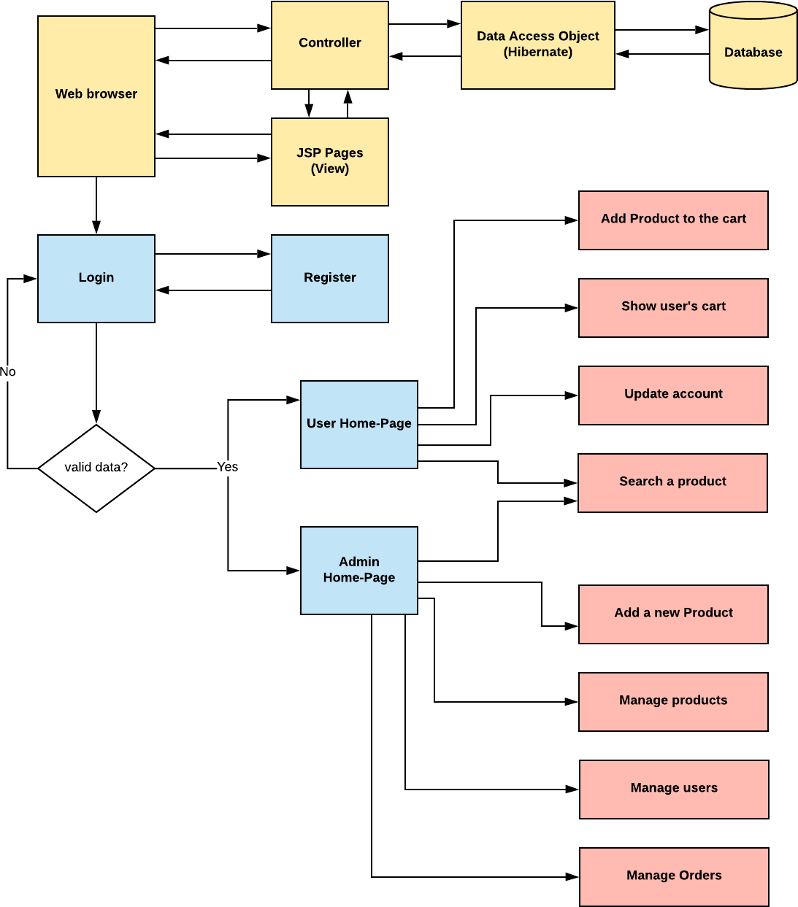

# Register page:

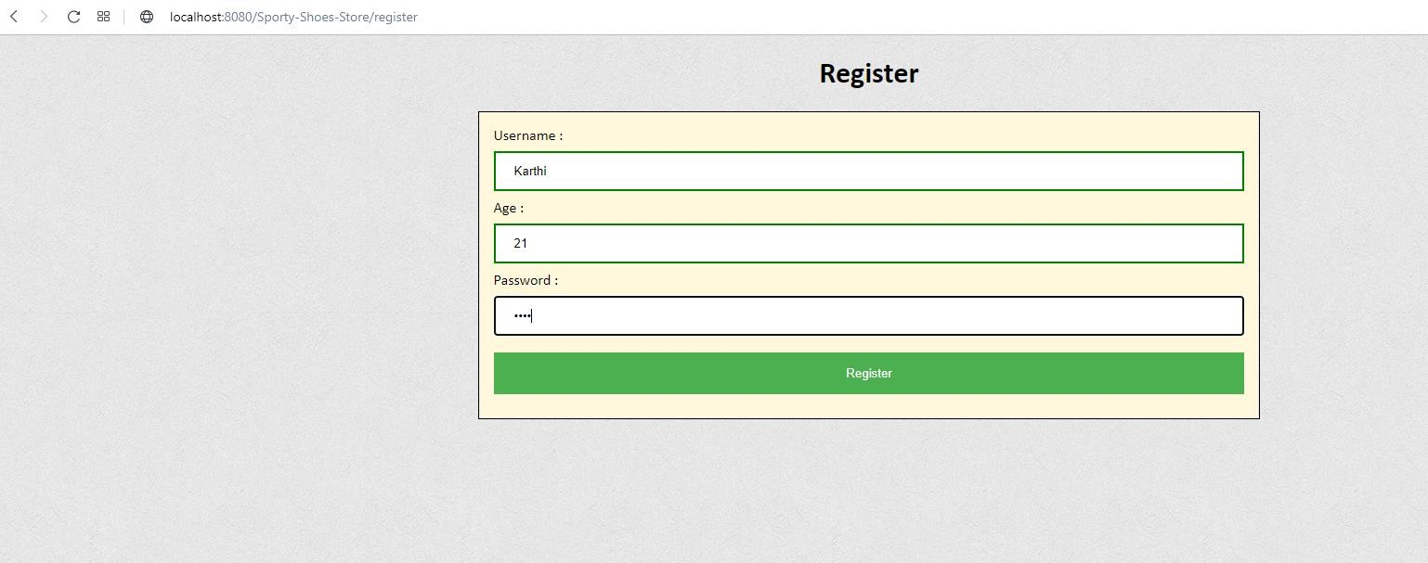

# Login page:

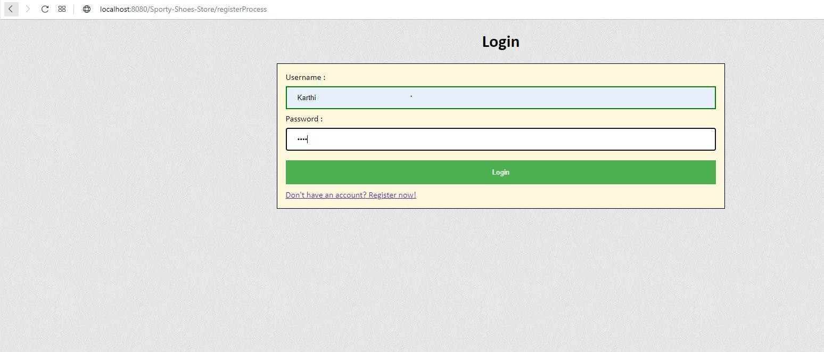

# User’s home page:

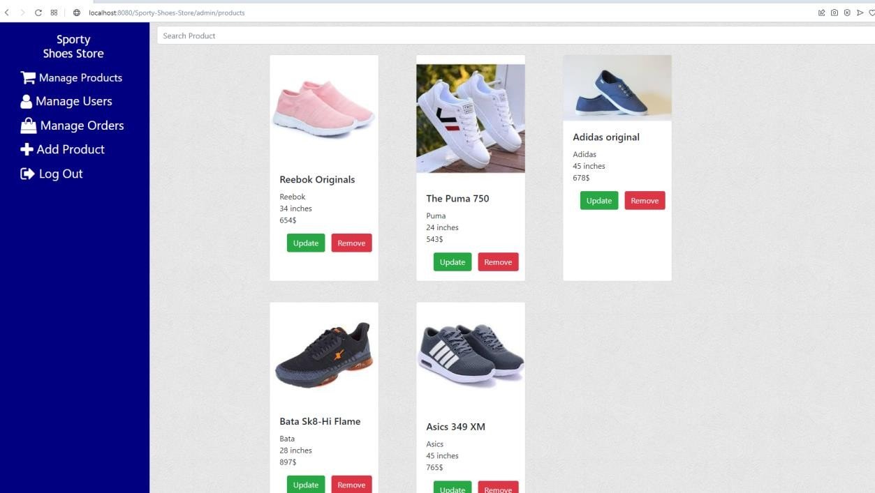

# User’s cart page:

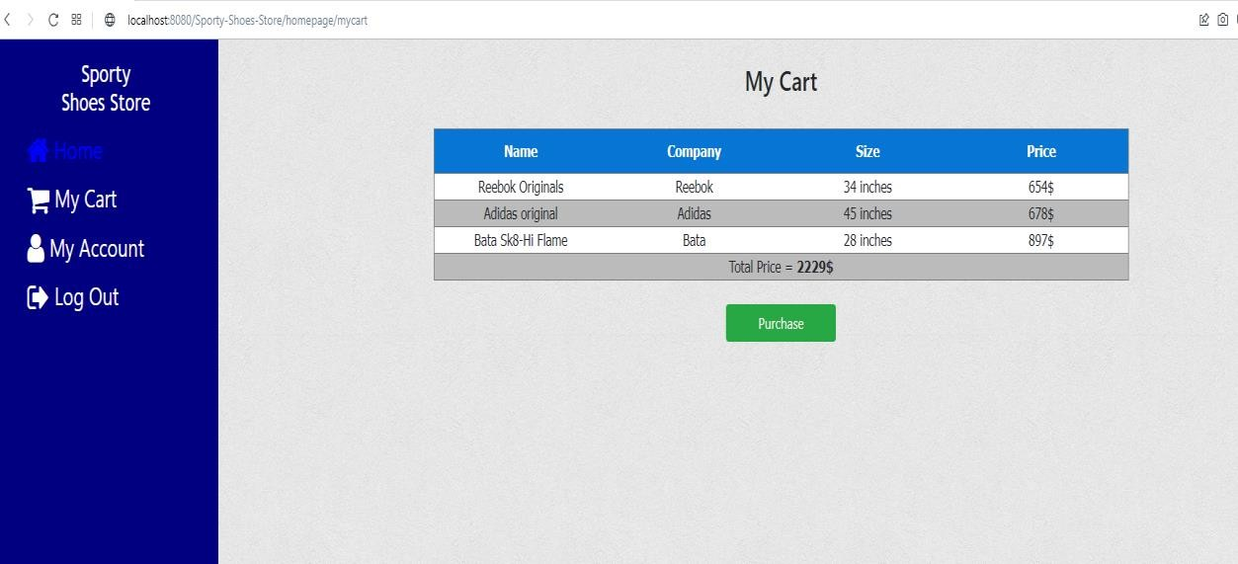

# User’s update account page:

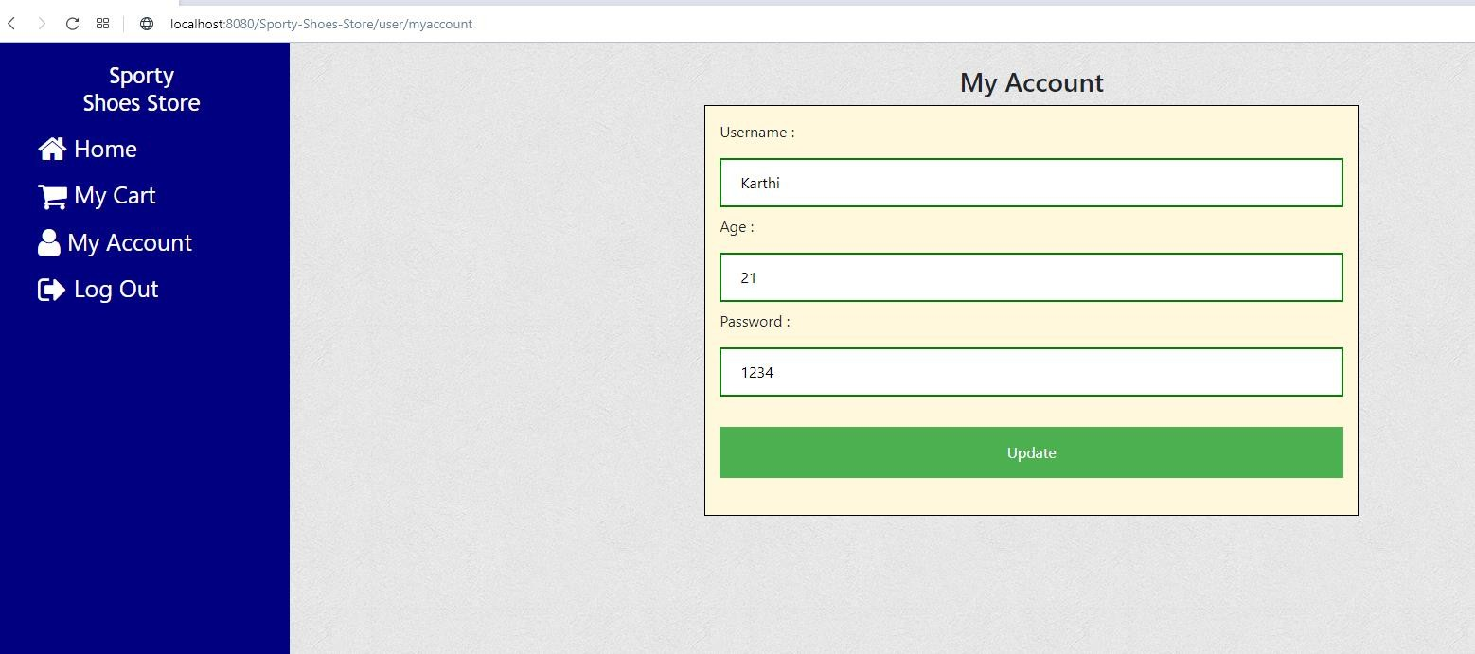

# Login as admin:

# Admin manage product page:

# :

# Update products page:

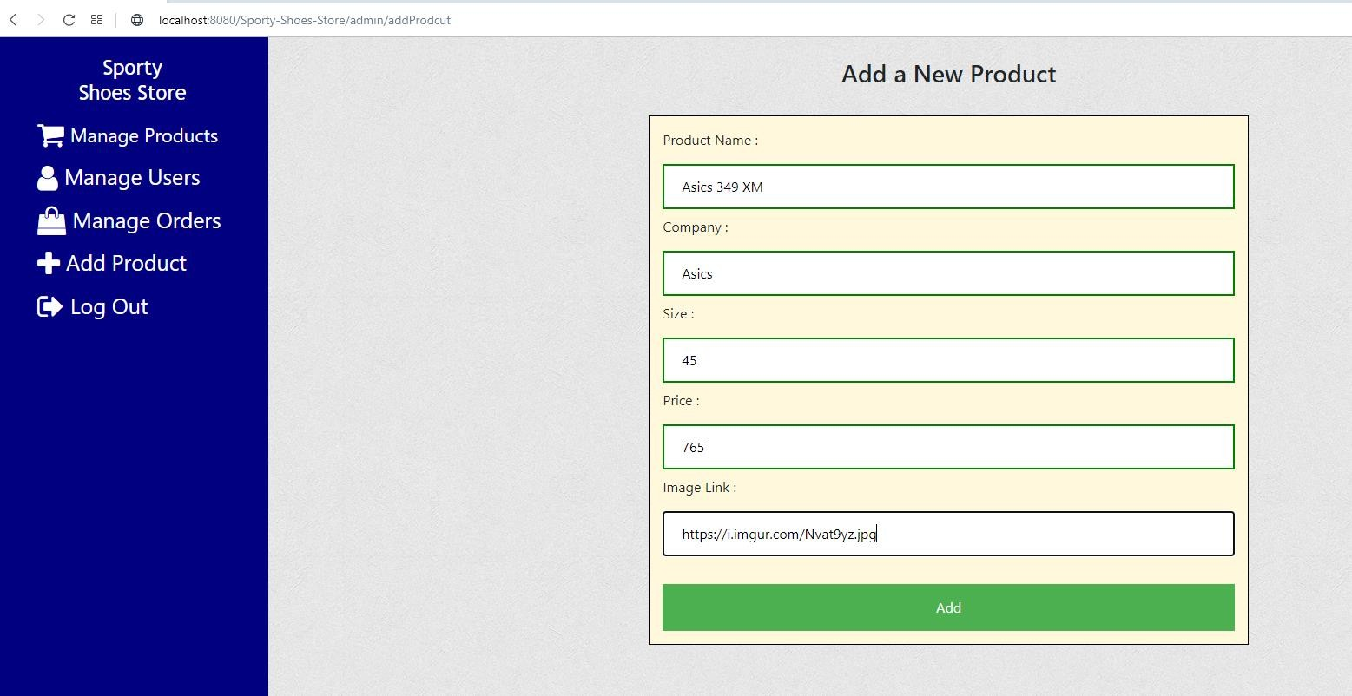

# Search a product by name:

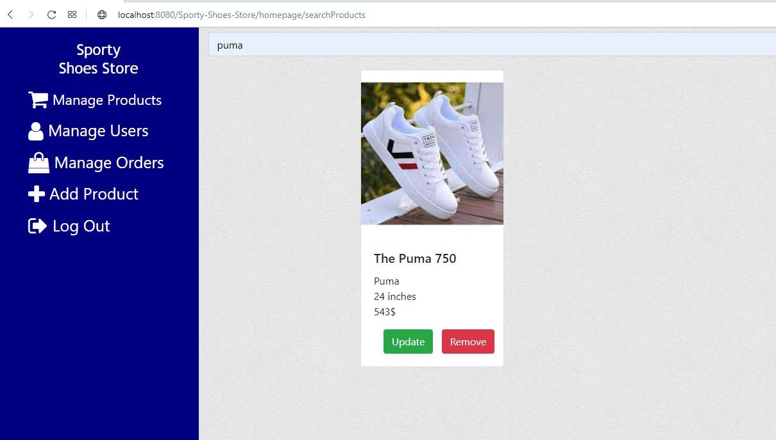

# Manage user’s page:

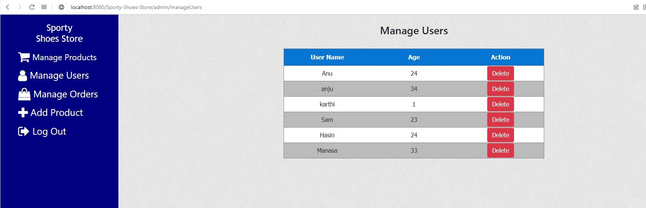

# Manage orders:

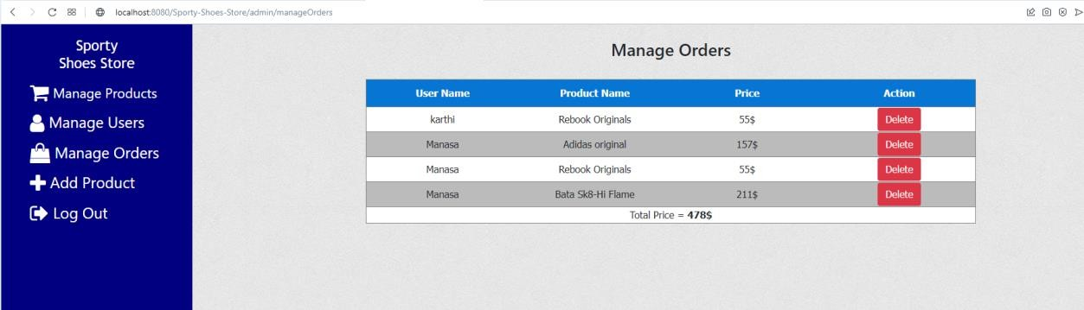

# Add new products to the system:

